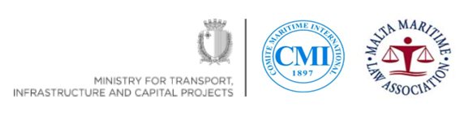

Malta Colloquium

Programme

High level technical Colloquium on a Draft International Instrument on Foreign Judicial Sales of Ships and their Recognition

Venue – Chamber of Commerce Valletta, Malta

Tuesday 27th February 2018

08:30 - 09:00 Registration

Moderator Suzanne Shaw, Vice President Malta Maritime Law Association,
Partner Dingli and Dingli Law Firm.

09:00 - 09:05 Welcome Ann Fenech
President Malta Maritime Law Association

09:05 – 09:10 Minister Ian Borg
Minister for Transport, Infrastructure and Capital Projects

09:10 - 09:25 Welcome and Introduction Stuart Hetherington,
President Comité Maritime International
Partner Colin Biggers & Paisley Pty Ltd - Australia

09:25 - 09:30 Welcome and Introduction Ryan Harrington,
Legal Officer - UNCITRAL Secretariat

09:30 - 10:30 PANEL ONE:

Available Enforcement proceedings

This Panel will talk about the enforcement processes in
various jurisdictions and the need for greater and more
uniform international recognition of Judicial sales.

Moderator - Ann Fenech - CMI Executive Councillor
Managing Partner Fenech & Fenech Advocates Malta

Camila Mendes Vianna Cardoso - Managing Partner - Kincaid, Mendes Vianna Advogados - Rio de Janeiro - Brazil

Jan-Erik Pötschke - Partner - Ahlers & Vogel - Hamburg
- Germany

Lawrence Teh – Administrator CMI
Senior Partner - Dentons Rodyk & Davidson
LLP - Singapore

Charles Buss - Partner - Watson Farley & Williams – London
- U.K.

Brooke Shapiro - Associate - Winston & Strawn LLP - New York – USA

10:30 - 11:00 COFFEE BREAK

11:00 - 12:00 PANEL TWO:

Current Challenges faced by Financiers, Creditors and Owners

This panel will discuss issues and concerns of financiers,
creditors and owners.

Moderator - Alexander von Ziegler - CMI Executive Councillor
Partner Schellenberg Wittmer AG Switzerland

Tilman Stein - Director and Senior Counsel Deutsche Bank
- Hamburg - Germany

Peter Laurijssen - Manager Legal Department - CMB Group
- Antwerp - Belgium

Cornelia Zammit German - CEO Falzon Group of Companies
- Malta

Simon Ward - Fellow / Chartered Shipbroker - Institute of Chartered Shipbrokers - London - UK

Ivan Sammut - Registrar General of Shipping & Seamen - Malta

Norman Martinez - Associate Professor - International Maritime Law Institute - Malta

12:00 - 12:30 QUESTION AND ANSWER SESSION

12:30 - 13:00 CONCLUDING REMARKS
Ryan Harrington and Stuart Hetherington

13:00 – 14:00 LUNCH

