CMI - IWG OPEN MEETING ON LIABILITY FOR ABUSIVE ARREST OF SHIPS
FOLLOW-UP QUESTIONNAIRE

Please complete this document and send it to the project rapporteurs: Edmund Sweetman (esweetman@icasf.net) and Professor George Theocharidis
(gt@wmu.se), which will collate and analyze the responses.
PLEASE NOTE THAT YOUR RESPONSES WILL BE PROCESSED IN A DISCRETE WAY AND THAT ONLY THE GENERAL CIRCUMSTANCES OF ANY CASE WILL BE RETURNED WITHOUT IDENTIFICATION OF THE PERSON WHO COMMUNICATED THEM.

Your name | (1.1) Jurisdiction
(1.2) How many years have you been practicing? | Over 20 years
(1.3) How many ship arrests occur in your jurisdiction, more or less, each year? | More than twenty
(2) Have you or your colleagues dealt with a case of wrongful arrest, or a case considered to be close to wrongfulness? | Yes
(3) Did this happen in your jurisdiction - or in another - and which one? | Ours
(4) If yes, please provide details of the case. | Doubt on the maritime claim. Damages remaining and due and principal dispute having been paid by the insurer
(5) Was there a procedural error or defect? | Yes
(6) Did the arrester use tactics to put pressure on the shipowner? | Yes, departure prohibited authorized by the maritime authority
(7) Was the purpose of the arrest to challenge:  7.1) the inherent jurisdiction of another State; or | No
7.2) the jurisdiction agreed by the parties to the dispute in an arbitration agreement; or | London
7.3) was the arrest made for the sole purpose of obtaining security for the claim? | Non-payment
(8) Was the warranty for the claim readily available? | Yes, the insurer has issued a guarantee
(9) What was the result in your example? | The court rejected the request and ordered the return of the guarantee to the insurer
(10) Do you want CMI to make or not proposals for some degree of consistency in the law on the improper arrest of ships? | Yes
1.1) counter-guarantee (ie obligation to deposit funds or equivalent guarantee in court); or  11.2) cross engagement to provide as a condition of arrest? | Obligation to deposit funds in an escrow account opened in the Bank of the debtor and managed by this bank to avoid indelicacies.
(12) What exemptions should be made in such a provision and for what protection? | Receivership in the hands of a banker
(13) What should be the test for wrongful arrest (ie, negligence, gross negligence or otherwise)? | Debtor bad faith and old claim
(14) In the event of a finding of unjustified arrest, what remedy would you consider appropriate / fair?  14.1) an allocation of the legal costs incurred by the S / O to file the W / A complaint? ; or | A release before the President of the Court.  The fees of the lawyers and bailiff fees and the costs of the registry and guarding of the merchant marine when the boat is forbidden to sail  Judicatum solvi deposit or guarantee deposited in a bank
14.2) damages for all losses suffered by the N / A, if it proves that they were caused solely as a result of the wrongful arrest? | Action for compensation  Article 1147 of the Civil Code in contractual matters
(15.1) Would you opt for an alternative remedy for damages?  15.2) if yes, what would you suggest? | Yes, application of the provisions of article 1147 of the civil code on damages to be awarded in the event of liability for or without fault of the debtor
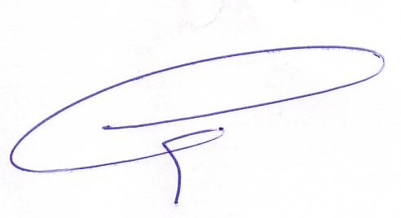
The President The General Secretary

