ANSWERS TO QUESTIONS

Question 1:
Is there legislation (or regulations) specifically dealing with classification society classification activities in your country?

Reply :
The Congo has ratified the IMO conventions (SOLAS and MARPOL).
So a technical inspection of the boat is required before the certificate of airworthiness is issued.

Question 2:
On what basis does your court retain jurisdiction over a third party claim against a classification society:

. Defendant's home,
. Locus delicti,
. Junction with other accused.
. Company rules
. Others?

Reply :
Defendant's domicile or
Locus delicti

Question 3:
How many cases - if any - concerning the liability of classification societies towards third parties have been decided in your country?

Reply :
Over a hundred

Question 4:
On which of the following subjects these decisions were rendered:
. Sinking or damage to a ship, including pollution damage?
. The action of cargo owners or their insurers or charterers?
. Sale of a used ship?
. Others?

Reply :
The action of cargo owners or their insurers or charterers?

Question 5:
What is the legal basis used or taken into account in decisions rendered in your country in the event of claims by third parties against classification societies:
. Offense
-2-
. Duty of care,
. Inaccurate statement made negligently,
. The use of the classification certificate,
. Others?

Reply :
. The use of the classification certificate,

Question 6:
Has a court in your country imposed liability on a classification society because of insufficient or incomplete rules?

Reply :
Yes

Question 7:
Is a classification certificate considered in your country as a certificate of airworthiness? If so, what is the reasoning?

Reply :
No. Resume the answer given to question n ° 1.

Question 8:
What importance has your courts given to the rules and regulations of the Society in their reasoning on the responsibility of classification societies vis-à-vis third parties?

Reply :
Our courts accept the substituted liability of classification societies by their insurers vis-à-vis third parties

Question 9:
What are the defenses available to a classification society sued in tort by a third party (assuming the facts are not disputed)?

Reply :
It must provide evidence that the issuance of the certificate of airworthiness meets IMO standards and was not purely indulgent. The Ship Inspection report will be cross-examined to demonstrate if it has been made in accordance with international standards.

Question 10:
Are classification societies able to invoke, in your country, the limitation of liability included in their rules or in classification certificates as a defense against tort action by a third party? If yes, please expand.

Reply :
Yes, classification societies can invoke the limitation of liability included in their rules or in classification certificates as a defense against tort action by a third party.

-3-

Question 11:
On the one hand, bodily injury or death would be caused by the negligence of a classification society and, on the other hand, economic loss, are they treated by your courts according to the same principles of law or different principles?
In such a case, please explain the differences.

Reply :
These problems are settled by our courts when they are seized of an action for compensation or compensation for damage or criminally in case of homicide or intentional or involuntary injuries (article 1213 penal code)

Question 12:
Please briefly explain the procedural rules applied and the inquiries carried out in your country on these questions concerning the responsibility of classification societies, with particular emphasis on the role of:

. Private or judicial experts;
. Witnesses.

Reply :
The procedural rules are those of common law, namely:
- Transport to the scene with experts and the maritime authority
- Investigative measures by hearing witnesses and all knowledgeable

Question 13:
Would a third party complaint against a classification society be subject to a time limitation or a prescription in your country?

Reply :
The third party liability action begins "from the day when the holder of a right knew or should have known the facts allowing him to exercise it. " It can run before the day when the victim becomes aware of the damage if it is established that the victim should have known the facts before and lapses after 5 years.

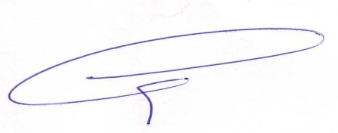
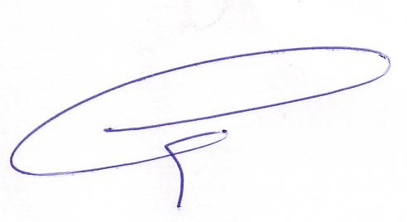

The President The General Secretary

