ANSWERS TO QUESTIONS FROM THE INTERNATIONAL MARITIME COMMITTEE ON EPIDEMICS AND PANDEMICS

PART 1: CURRENT PANDEMIC OF COVID-19

A. What action was taken by your jurisdiction during the current COVID-19 pandemic:
at. All ferry passengers and crew members are quarantined upon arrival in the Republic of Congo for a maximum period of 15 days.

b. All cruise ship passengers and crew members are quarantined upon arrival in the Republic of Congo, for a maximum period of 15 days.

vs. There are no restrictions regarding import or export or transit permits.

d. Upon arrival, the drivers and, if applicable, the crew members are quarantined for a period of 15 days and their trucks are disinfected.

B. Which authority (department of state or organization) in your jurisdiction was responsible for implementing these measures during the current COVID-19 pandemic:

e. The government of the republic was responsible for deciding on the measures.
f. Government spokesperson was responsible for providing expert advice on the deaths.
g. Yes, a Covid-19 pandemic response committee has been established by the Government.
h. No, there was no pre-existing plan to deal with the pandemic.
i. No
j. No, the Government of the Republic has not implemented such measures.
k. By taking decisions in accordance with the laws and regulations of the Republic.
l. The Government taken in the person of the Prime Minister and the members of the Covid-19 pandemic response committee.

C. Have the maritime authorities in your jurisdiction been consulted regarding decisions made in your jurisdiction during the current COVID 19 pandemic?

D. Were the people who made decisions in your jurisdiction during the current COVID 19 pandemic aware of the following requirements:
(i) Yes
(ii) Yes
(iii) Yes

D. Do you know if your jurisdiction has denied free circulation to a vessel during the current COVID-19 pandemic?
Revised epidemics and pandemics Questionnaire

-2-

PART 2
MOST RECENT EVOLUTION OF EBOLA (ongoing in the Democratic Republic of Congo since August 2018)

A. The state has banned the consumption of game meat and has closed all air and land borders to countries or regions affected by the Ebola outbreak.

B. The Government.

C. No, shipping authorities have not been consulted on decisions related to the Ebola outbreak
D. Were the people who made decisions (if any) in your jurisdiction during the last Ebola outbreak aware of the following requirements:
(iv) Yes
(iv) Yes
(v) yes
E. No.

Revised questionnaire on epidemics and pandemics

PART 3
GENERAL QUESTIONS CONCERNING WHO AND YOUR ADMINISTRATION OF THE IMLA QUESTION 2015. (IF YOU ANSWERED THESE QUESTIONS IN 2015, PLEASE IGNORE THEM UNLESS YOU WANT TO UPDATE IF YOU KNOW MORE INFORMATION)

Q1. Yes
Q2. Yes
Q3. Yes
Q4. Yes
Q5. Yes, it was made compulsory in January 2016.
Q6. Yes
Q7. No.
Q8. No
Q9. No
Q10. No
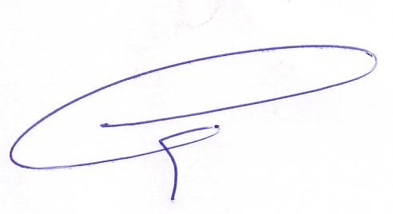
The President The General Secretary

