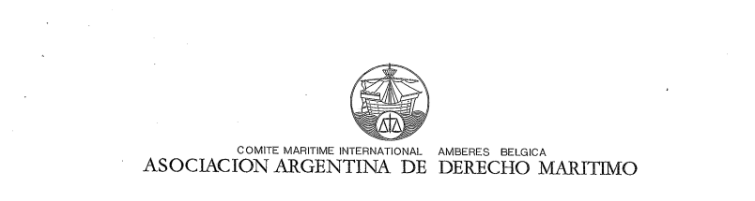

**Questionnaire for National MLA’s on Covid-19 Pandemic**

**RESPONSES OF THE ARGENTINE MARITIME LAW ASSOCIATION**

**A. What measures were taken by your jurisdiction during the current COVID-19 Pandemic:**

**a. In relation to the landing of passengers and crew members from ferries?**

There was no prohibition whatsoever until the first suspected case was reported, and the concerned ferry company decided to stop services. Afterwards, the government ordered the close of borders but allowed the repatriation of few Argentinean passengers and/or crewmembers who were abroad.

It should be emphasized that the main passenger ferry service is from Argentina to Uruguay, and viceversa.

**b. In relation to the landing of passengers and crew from Cruise ships?**

There is a prohibition of landing of passengers and crew from cruise ships in place. At the beginning of the pandemic, only the mooring of cruise ships was allowed where there were Argentinean passengers and/or crewmembers to disembark, and all the protocols as recommended by the WHO were followed.

The change and subsequent repatriation of foreign crewmembers has never been allowed.

**c. In relation to restricting or allowing the import, export or transit of cargo?**

No restrictions have been imposed. Ports have continued operating subject to the compliance with protocols set by the Argentinean authorities. In turn, each port has developed its own protocols based on such general guidelines.

**d. In relation to restricting or allowing the landing of drivers and their trucks from roll-onroll-**  
**off ferries?**

Each driver should seek and obtain an special permit and comply with safety protocols which application each port terminal is responsible for.

**B. Which authority (Department of State or Organisation) in your jurisdiction was responsible for implementing those measures during the current C OVID-19 Pandemic:**

**e. Which authority was responsible for deciding on the measures?**

The authority responsible for deciding on the measures taken was the Ministry of Transport through the Subsecretariat of Ports, Waterways and Merchant Navy and the Crisis Comittee for the Prevention of Covid-19, always in compliance with the general regulations established by the government under the advice of the Ministry of Health and the Committee of Infectious Disease Specialists.

**f. Which authority was responsible for providing expert advice on the measures?**

The Committe of Infectious Disease Specialists was responsible for provising such expert advice.

g. **Was there a formally established authority or committee for receiving and giving of expert advice?**

Yes, this formally established authority was the Crisis Committee for the Prevention of Covid-19 in the Subsecretariat of Ports, Waterways and Merchant Navy, in consultation with the Ministry of Health and the Committee of Infectious Disease Specialists.

**h. Did the authority implement a pre-existing plan to deal with the pandemic?**

Yes. The authority built on the then already existing plans, the plans taken by the countries going through the Covid-19 crisis since longer and the WHO's recommendations.

**i. Did the authority deviate from the pre-existing plan when dealing with the pandemic and why and when did it do so?**

The pre-existing plan was never applied as it was developed for the Ebola epidemic and no Ebola cases were reported.

In the case of the Covid-19 pandemic, a preventive lockdown was imposed on 19 March, and this lockdown has been partially lifted according to the number of confirmed cases in each area since then. Lockdown has not been loosened in the largest cities by population.

Measures are continually changing based on the number of confirmed cases in each particular city/town, in each particular province.

**j. Did your authority implement measures to achieve so-called herd immunity while avoiding overwhelming your hospitals, or did your authority seek to supress the virus** *ab initio* **or otherwise?**

The Argentinean authorities understand that the concept of "herd immunity" should not be applied. From the very beginning, they decided to suppress the visus ab *initio* by opting for a preventive lowdown in order to flatten the curve of contangion whilst hospitals and health centers were being better prepared for possible new suspected/confirmed cases.

The decision on which of the five lockdown phases will apply will depend on the number of confirmed cases per area.

The preventive lockdown (phase 1) has remained in place for over 100 days in the most populated areas.

**k. To what extent did your authority override health consideration in order to maintain the exchange of goods and services and the free movement of persons between your State**   
**and other states.**

Persons engaged in the international carriage of goods by air, land, sea, river or lake will only be allowed to enter the country with a special permit, always subject to the compliance with the protocols in place.

**l. Which authority or authorities was or were responsible for enforcing the various measures?**

Security forces were responsible for the enforcement of the various measures, namely the *Prefectura Naval Argentina* (local Coast Guard), the National Gendarmerie along with the Border Health Protection authorities of the Ministry of Health.

**B. Were maritime administrations within your jurisdiction consulted in relation to decisions taken within your jurisdiction during the current COVID 19 Pandemic?**

There is no reference to this in the documents perused, but we understand that they were consulted.

**C. Were those who took decisions in your jurisdiction during current COVID 19 Pandemic aware of the requirements of:**

**(i) The International Health Regulations 2005?**

**(ii) The FAL Convention 1965 (as amended)? (iii) The IMO-MLC Convention?**

We understand that the experts involved in the taking of measures should have been aware of said requirements. Authorities have always only referred to the WHO's recommendations/guidelines.

**D. Are you aware if your jurisdiction has denied free pratique to any vessel during the current COVID-19 pandemic?**

No vessel has even been denied free pratique. Due to one pilot having been infected, there was an attempt to have vessels on short voyages comply with the mandatory 14-day quarantine, but this has never materialised.

o-o-o-o-o-o-o-o-o-o-o

26 Julay 2020