The CMI has lost a good friend in Prof Dr Bülent Sözer
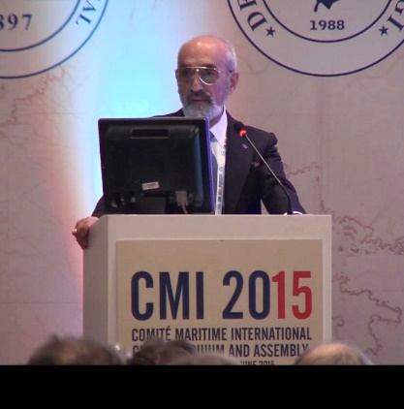

The CMI family will be greatly saddened to hear of the recent passing of Prof Dr Iur Bülent Sözer.
A notice of his passing and a short obituary may be found at his most recent academic home, the Institute of International Shipping & Trade Law of Swansea University (https://iist.blog/2023/12).

Bülent made many significant contributions to the work and fellowship of the CMI. As the then CMI Secretary-General I had the pleasure of working closely with him in organising the Istanbul Colloquium in 2015. Bulent co-chaired the Turkish organising committee with Samin Uman. I can say that it was largely because of Bülent’s optimism and enthusiasm that we went ahead with the Colloquium in the face of the then very recent emergence of ISIS on the world’s stage. The Colloquium was described by CMI President Stuart Hetherington at the Istanbul Assembly as “a stunning success” – credit largely due to Bülent.

For the past decade Bülent has been a staunch supporter of the yCMI Essay Prize, and on three occasions (undoubtedly beyond the reasonable call of CMI duty) he happily agreed to act as one of three judges. His opinions were unfalteringly fair and thorough. Being a generous minded soul, he was happy to give high marks to reward good efforts, but did not shy away from knocking submissions he considered below standard.

CMI members will miss his regular attendance and at times spirited contributions at CMI international events. In addition to his yCMI Essay work, his most recent contribution to the CMI has been as a member of the Maritime Autonomous Surface Ships and Vessel Nomenclature International Working Groups. He was immensely proud to have his last book published in September last year: Unmanned Ships and the Law [Informa, 2023] is a fitting tribute to a practice and academic life well spent.

I was privileged to be referred to by Bülent, in his characteristic expansive and ebullient style, as his venerable and esteemed friend. Sadly I was not able to travel to Piri Reis University to celebrate with him the award to him of an Honorary Doctorate in October 2021. That honour recognised his half century of teaching and writing in shipping law – he once told me that his teaching career started in March 1972 when he was dropped into the deep end by his Dean to teach carriage of goods by sea. “Fifty years in the pulpit” he told me proudly. The many students who benefitted from his passion for teaching and for his subject will no doubt join us in lamenting the passing of a good man, and a great character.

John Hare
Past Secretary-General
Comité Maritime International

