ΕΛΛΗΝΙΚΗ ΕΝΩΣΗ ΝΑΥΤΙΚΟΥ ΔΙΚΑΙΟΥ
ASSOCIATION HELLENIQUE DE DROIT MARITIME | 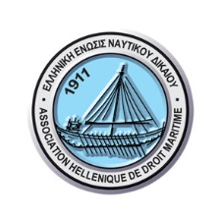 | HELLENIC  MARITIME LAW ASSOCIATION
To the CMI
Piraeus 10 April 2020

Re : Reply to the COVIT 19 questionnaire

- Are the Courts in your jurisdiction open and functioning as per normal?
No; proceedings have been suspended but for very limited exceptions. Court offices are attended only by minimum service personnel.

- If not, are there any exceptions to the arrest of ships and / or are other injunctive or enforcement procedures available?
Yes, for urgent matters involving preservation of rights (such as ship arrests, freezing of accounts and other security measures); not for enforcement by way of foreclosure.

- Can Judicial Sale of Ships still take place?
No.

- Do you know how long the Courts in your jurisdiction will be closed for ?
According to the latest information they are closed until 27 April 2020.

- Is the flag registry in your jurisdiction (if applicable) operating as per normal in terms of the registration of ships and registration of mortgages and deletion of same ?
Greek ships’ registries are in operation with minimum service personnel. Registration of sales, mortgages etc may be done by appointment.

- Has your flag administration issued any special exemptions for the period of the Pandemic?
Ships’ certificates may be extended by up to three months and seafarers’ certificates have been extended by six months (see details at http://www.hcg.gr/sites/default/files/article/attach/hmaCovid192signed.pdf)

A summary of the measures taken by the Hellenic Maritime Administration (including reporting requirements and restrictions to ships calling at Greek ports) may be found at http://www.hcg.gr/sites/default/files/article/attach/Hellenic%20Maritime%20Administration%20Covid%2019%20v.27.03.doc

For the Hellenic MLA
John Markianos-Daniolos
Vice President

