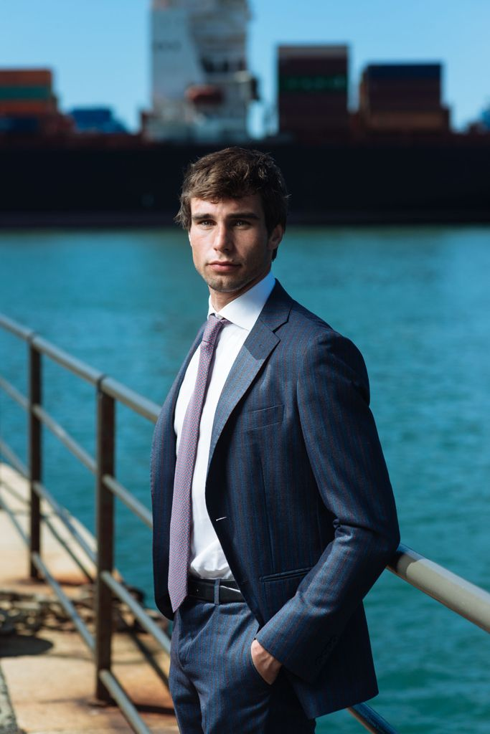

Alberto Bregante was born in Genoa in 1994. He graduated in law at the University of Genoa in October 2018 (hons, specialising in European and International Law of the Sea with a dissertation on “Ship-recycling in International and European Law”). During his studies he took part in the Erasmus+ Program, spending two semesters at Universidad de Oviedo (Spain), one semester at Université de Bordeaux (France) and one semester at Universidade Nova de Lisboa (Portugal). The studying - abroad - experiences allowed him to learn about foreign legal systems and to improve his language skills (English, French, Spanish and Portuguese).
In January 2019, few months after graduation, he joined a traditional Maritime Law Firm based in his hometown where is currently practising maritime, transport and insurance law."
UNQUOTE
I hope both the photo and the short biographical note are in good order for publication on the CMI website. Mrs. Evelien Peeters is in copy.
I would kindly ask You, if possible, to let me know once my essay will be published on CMI website and I would like to sincerely thank you again for this great opportunity the CMI is giving me.

